**Adding Challenges**

**Fitivity Inc.**

Nathan Doe

Table of Contents

Challenge Data Schema: 3

Adding Challenge: 4

Activity: 4

Levels & Days: 5

Exercise: 6

# Challenge Data Schema:

There are three tables in the Challenge schema – Challenge, ChallengeDay, and Exercise. Challenge day has a parent object of type Challenge, and Exercise has a parent object of type ChallengeDay.

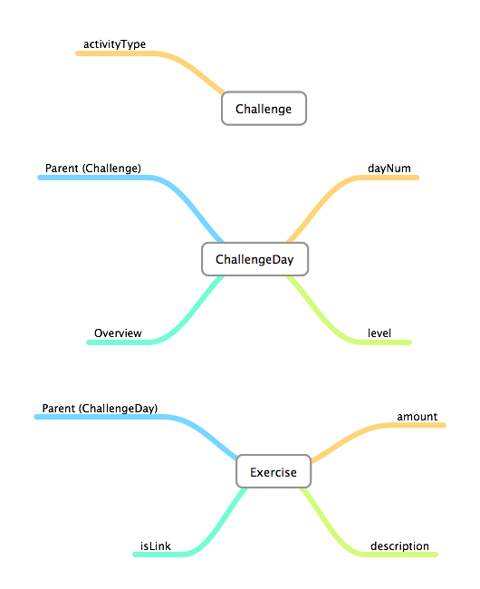

# Adding Challenge:

There are three sections you need to add data to add a new challenge.

## Activity:

The app looks at the Challenge table to get a list of activities that have challenges. Once you add/remove a row from this table the app will no longer show the activity (upon relaunch).

1. Login to Parse and navigate to the *Data Browser*.
2. Click on the *Challenge* Class on the left of the screen.
3. Click the  *+Row* button to add a new row.
4. When the new row is added, double click the empty cell in the activityType column. Enter in the type of activity you wish to have challenges. **NOTE:** The spelling must match what is in the *Activity* table – including case.
5. Once done press the *Enter* key on your keyboard to save the entry.
6. Next copy the *objectId* value that is automatically generated (you will use this in the next step).

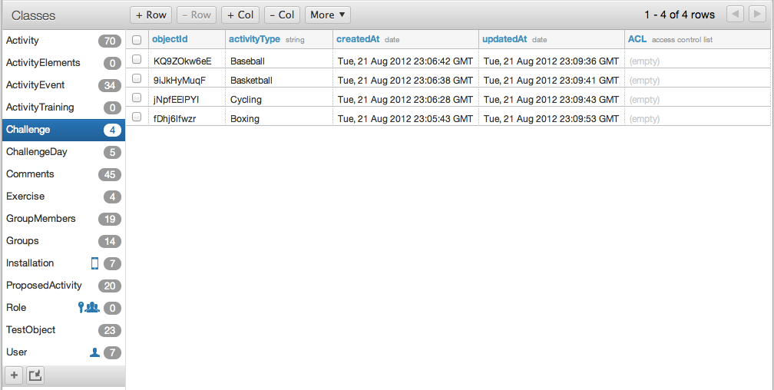

## Levels & Days:

Each challenge has a series of levels – and each level has a series of days. For each ChallengeDay object you will need to assign which level it is in, and which day it is for the level.

1. Click on the *ChallengeDay* class on the left side of the screen.
2. Click on the *+Row* button to add a new row.
3. When the new row is added, double click the cell in the *parent* column. Paste the vale you copied from the *Challenge* *objectId* in the previous section into here. **NOTE:** This value must have the same *objectId* as the *Challenge* you just created – if not it may cause unexpected app functionality. You may have multiple rows with the same *parent*.
4. Double click the cell in the *dayNum* column. Enter the numeric value for the day in the level.
5. Double click the cell in the *level* column. Enter the numeric value of the level this day should appear in.
6. Double click the cell in the *levelLength* column. Enter in the value of how long this level should take (ex. “Two Weeks”). **NOTE:** While you can enter a *levelLength* for each row, the only one that will be displayed in the app is the one for *dayNum* = 1 for each level.
7. Double click the cell in the *overview* column. Enter an overview for this day’s challenges.
8. Lastly, copy the *objectId* value that is automatically generated (you will use this in the next step).

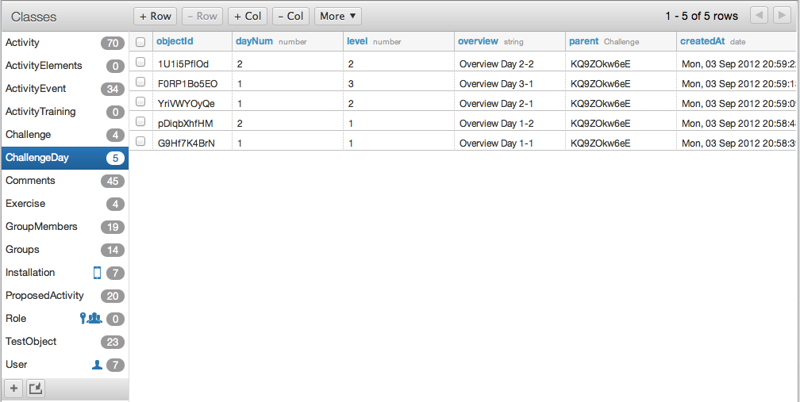

## Exercise:

These objects represent an individual exercise/task that appears in a day. Each exercise can either have a URL to a YouTube video, or an image.

1. Click on the *Exercise* class on the left side of the screen.
2. Click on the *+Row* button to add a new row.
3. Once the new row is added, double click the cell in the *parent* column. Paste the value of the *ChallengeDay objectId* you copied in the previous step. **NOTE:** This value must have the same *objectId* as the *ChallengeDay* you just created – if not it may cause unexpected app functionality. You may have multiple rows with the same *parent*.
4. Double click the cell in the *amount* column. Enter the amount of the exercise/task the user should do. **NOTE:** This is the value that will show as a footer below the exercise.
5. Double click the cell in the *description* column. Enter in the name/description of the exercise (ex. Bunting).
6. Double click the cell in the *isLink* column. Enter “true” if this exercise is going to have a YouTube link. Enter “false” if the exercise is going to have a picture.
7. If the exercise has a picture, double click thecell in the *picture* column (otherwise skip this step). Click on the *Upload File* button that appears.
   1. Navigate your computer to find the picture you want to upload.
   2. Click the *Choose* button to upload the file to Parse.
8. If the exercise has a YouTube video, double click the cell in the *url* column (otherwise skip this step). Copy the URL of the YouTube video from your browser and paste it into this cell.

